Software Development Models
1. Agile Model
1.1 Overview
The Agile Model is an iterative and incremental software development approach focused on flexibility, quick delivery, customer collaboration, and continuous improvement. Instead of delivering the entire product at once, Agile breaks the work into small chunks called iterations or sprints (usually 1–4 weeks).
Agile responds quickly to changes in requirements, making it ideal for dynamic and evolving projects.
1.2 Key Characteristics
- Iterative development with frequent releases
- Continuous customer feedback
- Flexible to requirement changes
- Daily communication (Scrum meetings)
- Working software delivered early and repeatedly
- Strong collaboration between cross-functional teams
1.3 Agile Process Steps
- Requirement Gathering (Epics, User Stories)
- Sprint Planning
- Design & Development
- Testing during the sprint
- Sprint Review / Demo
- Retrospective to improve process
- Deployment and Maintenance
1.4 Advantages
- Fast delivery and early ROI
- Easily adapts to requirement changes
- High customer satisfaction
- Lower risks due to frequent feedback
1.5 Disadvantages
- Requires experienced teams
- Hard to estimate cost & timelines
- Needs active customer involvement
1.6 Best Suited For
- Projects with frequently changing requirements
- Startups, evolving products, AI/ML prototypes
- Time-sensitive applications
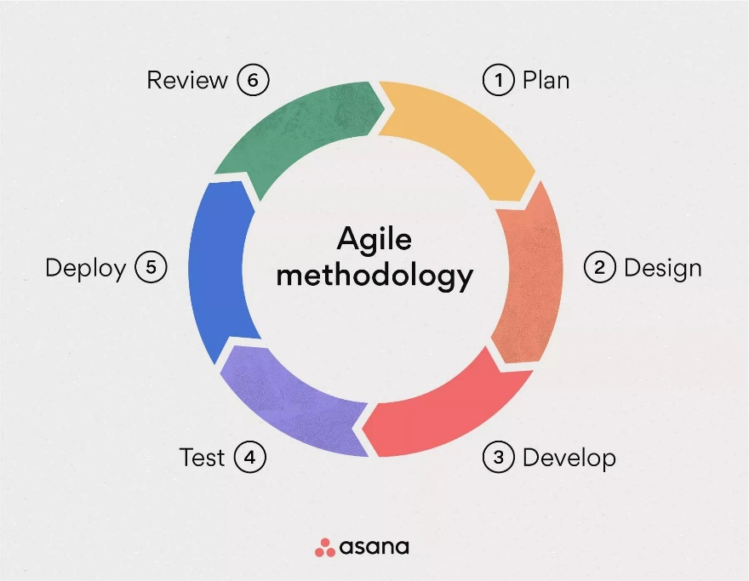
2. Waterfall Model
2.1 Overview
The Waterfall Model is a linear and sequential SDLC model where each phase must be completed before moving to the next. It is one of the oldest and simplest development approaches.
No overlapping phases occur, and changes are difficult once a phase is completed.
2.2 Waterfall Phases
- Requirement Gathering
- System Design
- Implementation (Coding)
- Testing
- Deployment
- Maintenance
2.3 Key Characteristics
- Strict phase-by-phase progression
- Detailed documentation
- No flexibility for changes
- Easy to manage for stable requirements
2.4 Advantages
- Simple and easy to understand
- Well-structured with clear milestones
- Useful for projects with fixed requirements
2.5 Disadvantages
- Not suitable for changing requirements
- Late discovery of issues (in testing phase)
- High risk and uncertainty
2.6 Best Suited For
- Government, banking, defence projects
- Projects with very stable and well-defined requirements
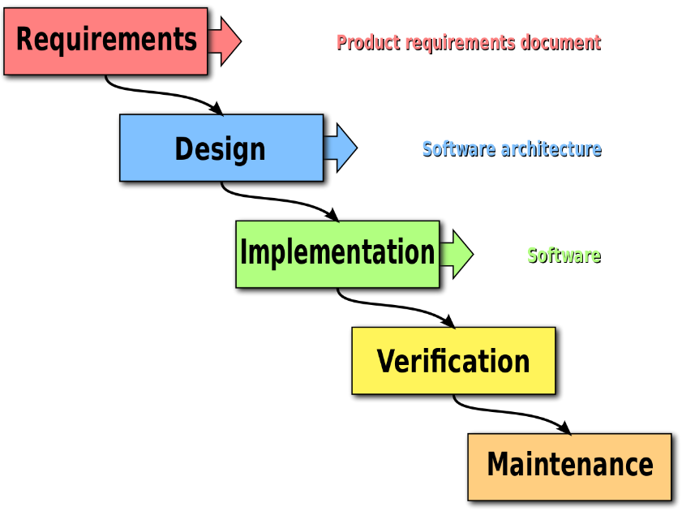

3. V-Model (Validation & Verification Model)
3.1 Overview
The V-Model is an extension of the Waterfall Model where testing is planned in parallel with development phases. It visually forms a “V” shape showing how each development phase has a corresponding testing phase.
3.2 Structure of V-Model
Left Side (Verification Phases)
- Requirement Analysis
- System Design
- Architecture Design
- Module Design
Right Side (Validation / Testing Phases)
- User Acceptance Testing (corresponds to Requirement Analysis)
- System Testing (corresponds to System Design)
- Integration Testing (corresponds to Architecture Design)
- Unit Testing (corresponds to Module Design)
3.3 Key Characteristics
- Testing happens early (test planning alongside design)
- Strong emphasis on quality
- Very structured and disciplined approach
3.4 Advantages
- Defects detected early
- Clear relationship between development and testing
- High reliability and quality
3.5 Disadvantages
- Not suitable for projects with changing requirements
- Very costly and time-consuming
- No early prototypes
3.6 Best Suited For
- Healthcare, aviation, safety-critical systems
- Projects needing high-quality testing and documentation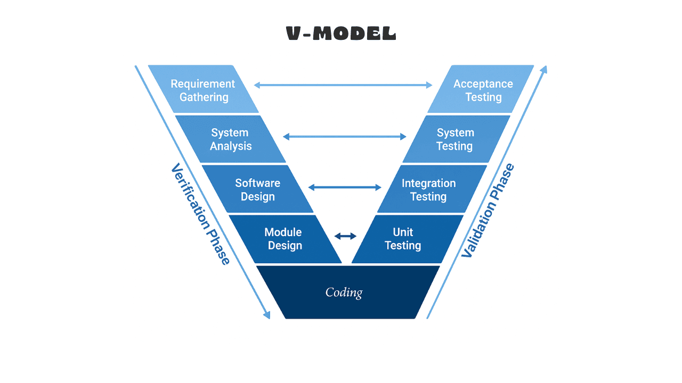

4. Spiral Model
4.1 Overview
The Spiral Model is a risk-driven, iterative development model combining elements of Waterfall and Prototyping. Development happens in spirals (cycles), each containing planning, risk analysis, engineering, and evaluation.
It is ideal for large, complex, and high-risk projects.
4.2 Spiral Model Phases
Each spiral cycle consists of:
1. Planning Phase
- Define objectives
- Estimate scope and constraints
2. Risk Analysis Phase
- Identify and analyse risks
- Build prototypes to reduce risk
- Evaluate alternatives
3. Engineering Phase
- Development and testing of modules
- Refinement with each cycle
4. Evaluation Phase
- Customer feedback
- Review of requirements
- Decide next spiral or release
4.3 Key Characteristics
- Focuses heavily on risk mitigation
- Iterative & incremental delivery
- Uses prototypes frequently
4.4 Advantages
- Great for large, complex systems
- Early detection and reduction of risks
- Flexible to requirement changes
- Continuous customer involvement
4.5 Disadvantages
- Very expensive
- Requires risk-analysis expertise
- Difficult to manage and document
4.6 Best Suited For
- Large enterprise systems
- Projects with high risk (financial, safety, mission-critical)
- Long-term R&D projects
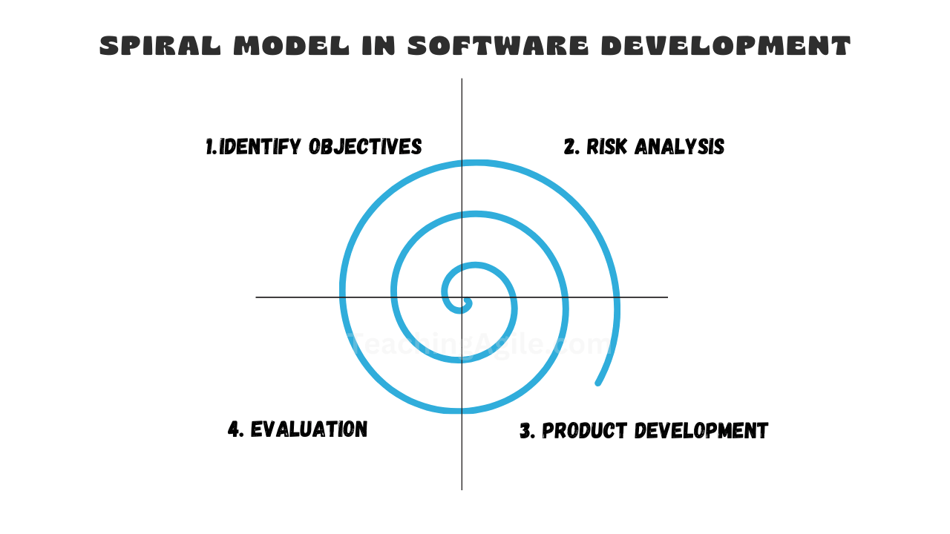

Combined Summary Table
Model | Type | Flexibility | Cost | Risk | Best For
Agile | Iterative | Very High | Medium | Low | Dynamic, evolving projects
Waterfall | Linear | Very Low | Low | Medium | Fixed requirement projects
V-Model | Sequential with Testing | Low | High | Low | Safety-critical systems
Spiral | Risk-driven Iterative | High | Very High | Very Low | Complex, high-risk systems

